REPORT 2024 GRADUATE SURVEY
The study was organized to obtain feedback from 2024 graduates of the K. I. Satbayev Kazakh National Research Technical University regarding professional outcomes, satisfaction with the quality of education, and the alignment of acquired competencies with labor-market requirements. The survey was conducted online and included participants from all seven university institutes:
- Institute of Automation and Information Technologies;
- O. A. Baikonurov Mining and Metallurgy Institute;
- T. Basenov Institute of Architecture and Construction;
- K. Turysov Institute of Geology and Oil and Gas;
- A. Burkitbayev Institute of Energy and Mechanical Engineering;
- E. Turkebaev Institute of Project Management;
- M. Tynyshpayev School of Transport Engineering and Logistics.
The questionnaire provided material for analysis, including data on current employment status, salary levels, fields of activity, further study, and graduates’ assessment of the educational process at the university. The results are used to prepare an internal report and to provide information for the QS Graduate Employability Ranking, and also serve as a basis for improving curricula, strengthening the practical orientation of education, and deepening ties with employers. The report presents aggregated survey results in percentage and absolute terms.
Question 1: If you had to choose a major and a university again, what would you do?
Most participants (59%) confirmed that they would choose the same major and Satbayev University again, indicating a high level of satisfaction with their choice. However, around 30% of respondents expressed a desire to change either the university or the major, which may signal the need to analyze reasons and potential improvements.
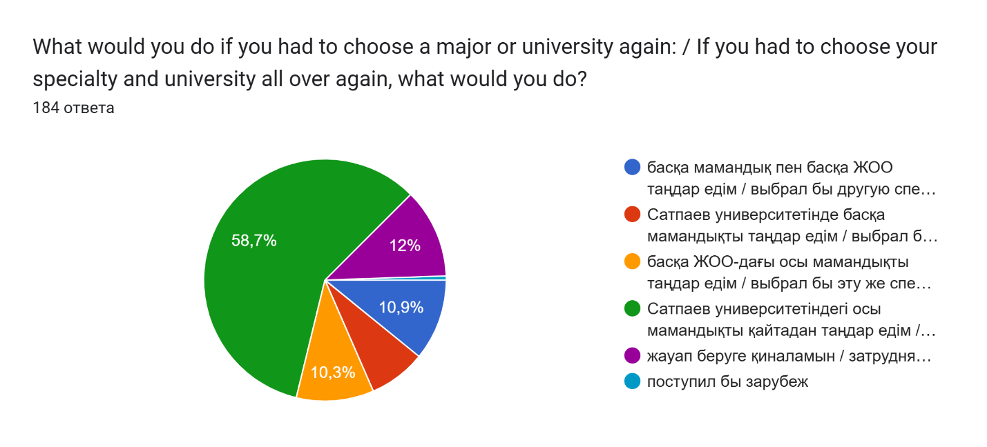
Question 2: Are you satisfied with the level of professional training you received at the university?
Half of the respondents (51.9%) are fully satisfied with the level of professional training they received. However, 36.6% believe the training was insufficient in certain aspects, and 7.7% are not satisfied at all. This may serve as a basis for reviewing academic programs and improving educational quality.
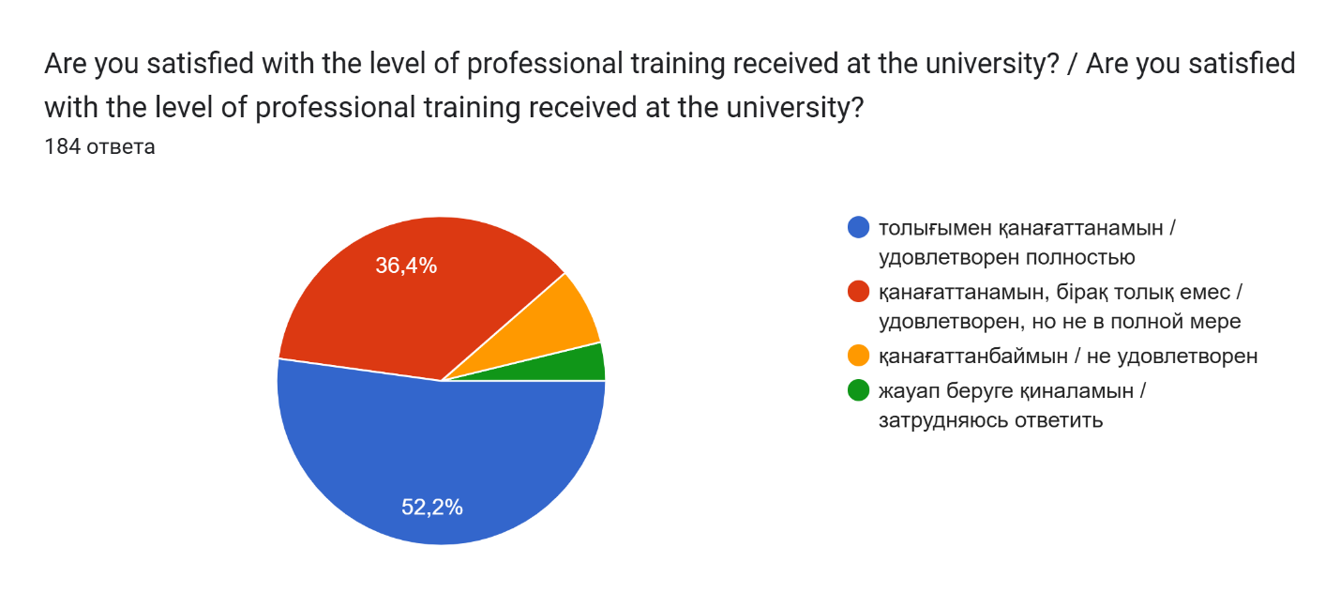
Question 3: On a 10-point scale, rate your satisfaction with how well the educational program (courses, internships) prepares highly qualified specialists in your profession.
The majority of students (82.5%) rated the alignment of the educational program with the training level of highly qualified specialists at 7 points or higher, indicating high satisfaction. However, a small share of respondents (about 9%) gave scores below 6, which may indicate specific areas for improvement in courses or internships.
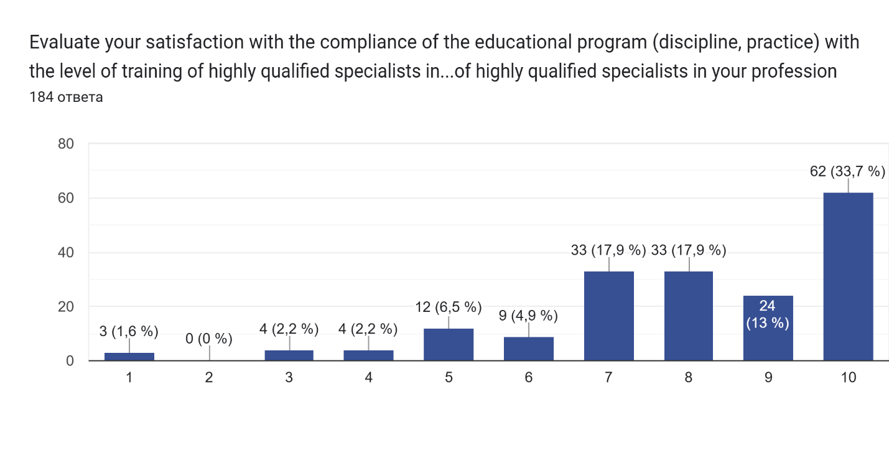
Question 4: What would you like to see added to improve the level of training in your specialty—what could be incorporated into the educational program?
Most graduates (about 45–50%) noted the need to enhance the practical orientation of training. Their most frequent suggestions included extending the duration of industrial internships, introducing real-world cases and projects in cooperation with employers, and engaging industry professionals to teach classes.
About 25% of respondents indicated the need to modernize curricula, including updating courses and adding contemporary digital technologies, programming, 3D modeling, engineering design, and other up-to-date competencies in demand in their professions.
Approximately 15% of graduates proposed paying more attention to the development of soft skills—communication, teamwork, project management, and leadership.
Another 10% recommended improving the material and technical base: updating laboratory equipment, computer classrooms, and specialized software.
A small proportion of respondents (about 5%) emphasized the importance of faculty development and regular exchange of experience with foreign universities.
Overall, graduates show interest in improving training quality and seek a closer link between the educational process and the practical tasks of their future professional activities.
Question 5: Which of the following qualities or skills do you believe you mastered as a result of studying at Satbayev University? (select no more than 3 options)
Almost half of the students (48.1%) believe that studying at Satbayev University provided them with strong professional training. More than a third noted the development of critical thinking (38.8%) and teamwork skills (35.5%). About a quarter indicated leadership (25.7%) and decision-making (24.6%). Fewer than 20% selected public speaking, time management, conflict resolution, and negotiation skills. This may indicate the need to strengthen programs aimed at developing soft skills.
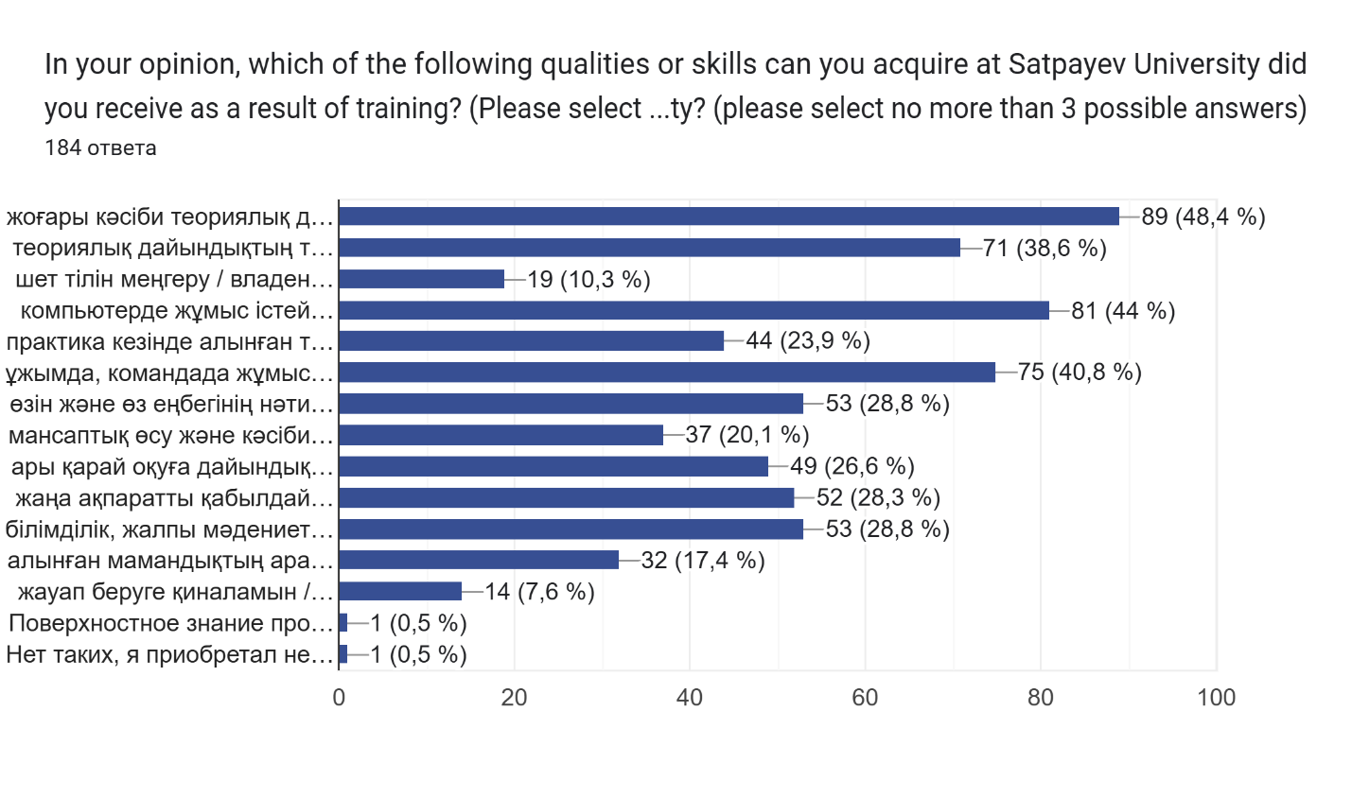
Question 6: On a 10-point scale, rate the level of education you received at Satbayev University.
More than half of the graduates (64.7%) rated their education at 8–10 points, reflecting a high level of satisfaction with education quality. A score of 6–7 was given by 21% of respondents, and low scores (1–5) by about 14% of participants.
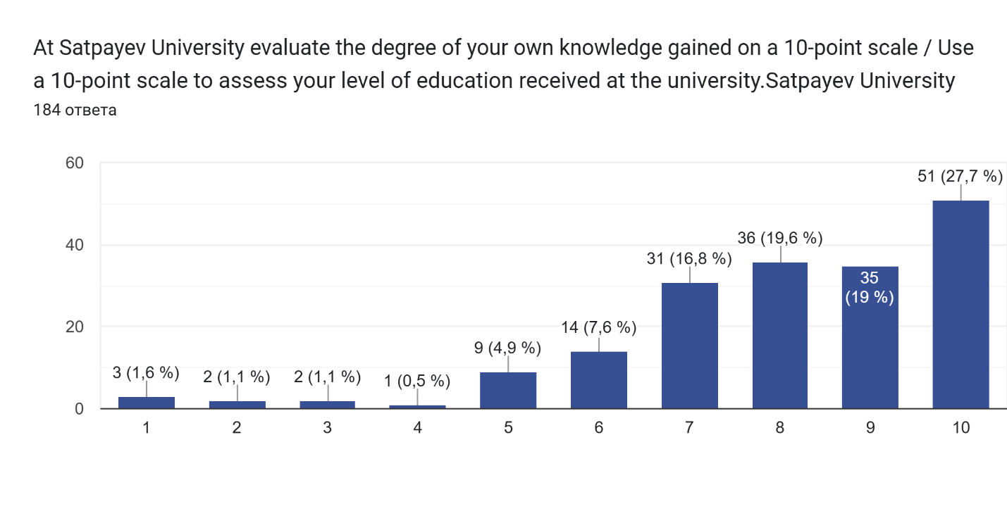
Question 7: Did the university support your career development (motivation programs, internships, etc.)?
More than half of the students (56.8%) noted that the university supported their career development, including motivation programs and internships. However, almost a quarter (24.6%) did not feel such support, and 18.6% found it difficult to answer—possibly indicating insufficient awareness of career opportunities.
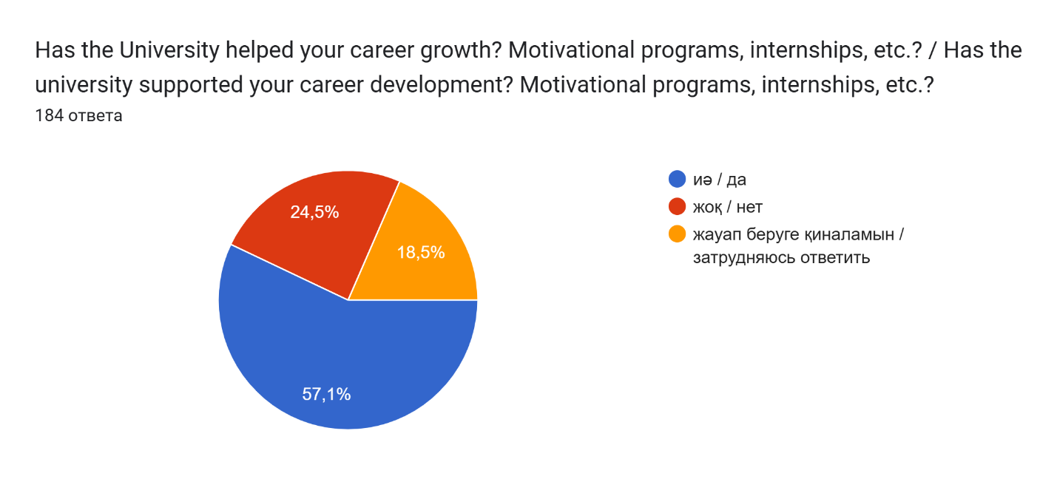
Question 8: Did the university help you find an internship?
More than half of the students (56.8%) noted that Satbayev University helped them find an internship. Almost a third (29.5%) did not receive such support, and 13.7% found it difficult to answer—again suggesting that students may not be fully informed of internship opportunities.
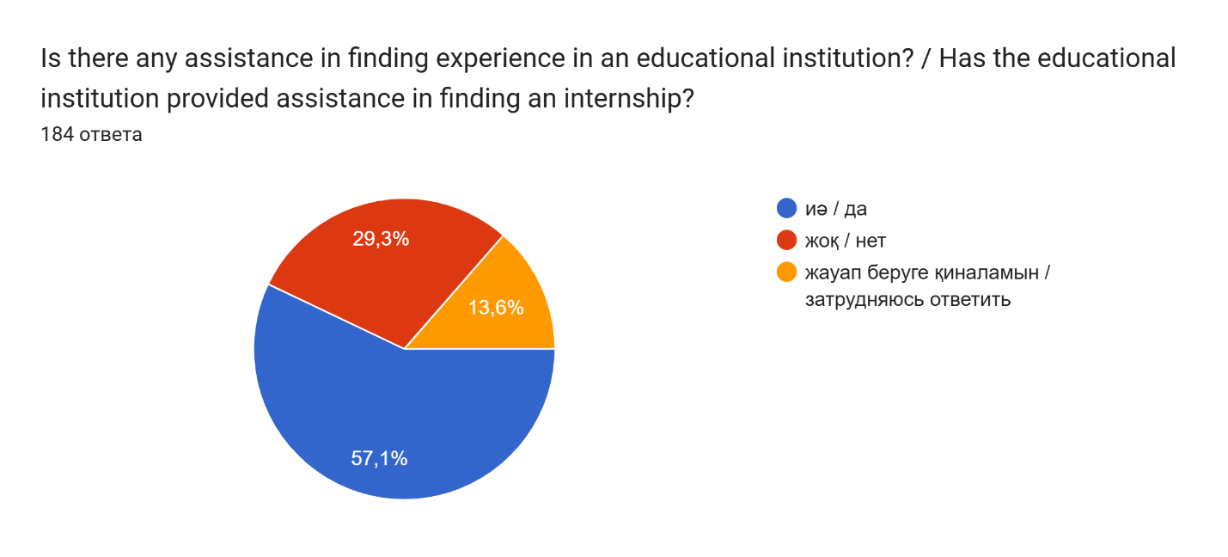
Question 9: Rate the quality of industrial internship.
Most students evaluated the quality of industrial internship positively: 45.4% were satisfied and another 41% were rather satisfied. Thus, more than 86% expressed overall satisfaction.
Only 13.6% reported dissatisfaction: 7.7% were rather dissatisfied and 6% completely dissatisfied. This may indicate the need for targeted improvements in certain aspects of internships, such as content, organization, or university supervision.
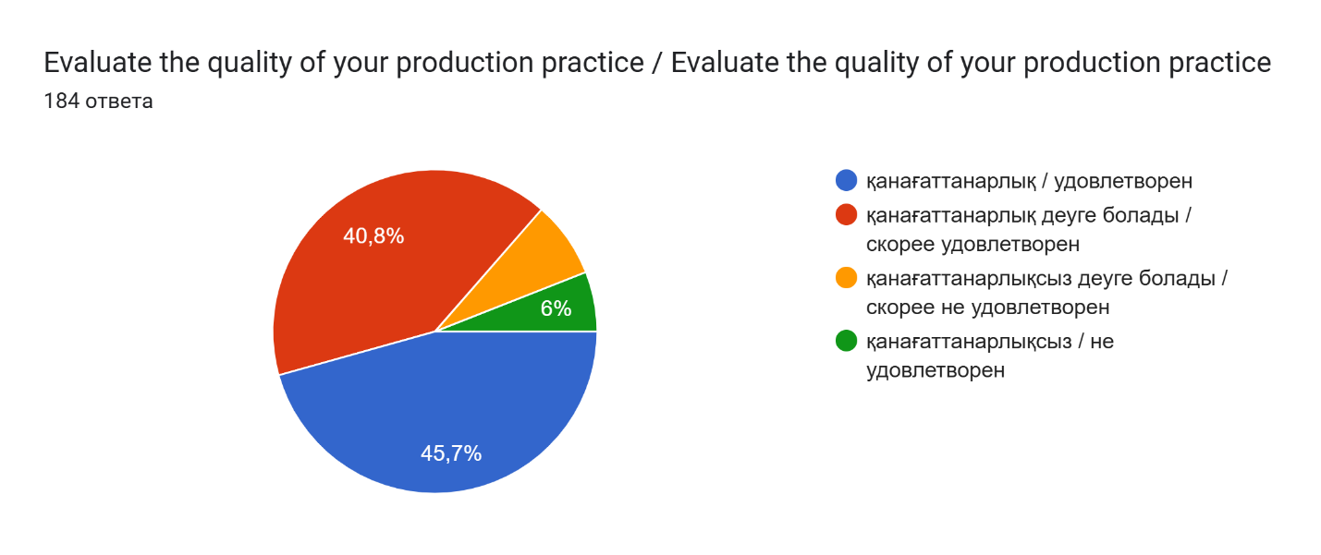
Question 10: Did the university provide support with employment?
Most students (44.3%) noted that the university supports employment through job fairs. Another 22.4% reported being offered internships leading to employment, and 8.7% received letters of recommendation.
However, 21.3% indicated that they did not receive support from the university. Isolated responses (less than 1%) pointed to individual assistance from instructors or departments, as well as students finding jobs on their own. This may suggest a need for more systematic and transparent career-development support for all students.
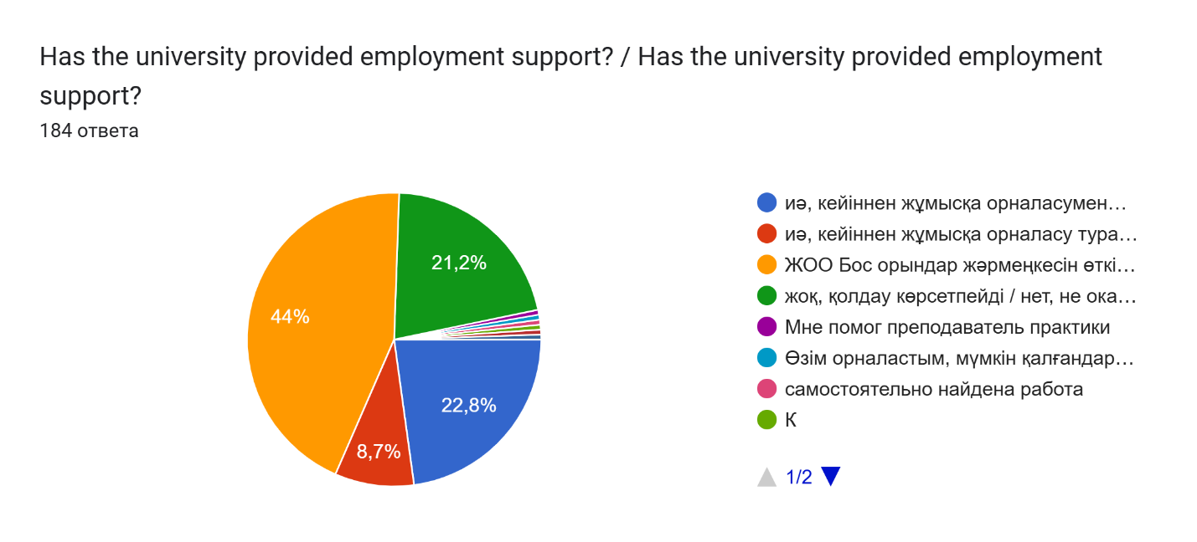
Question 11: In your opinion, what needs to be changed in the learning process (or incorporated into study plans) to improve the quality of professional training at Satbayev University? (no more than 3 options)
More than half of students (53.6%) believe it is necessary to reduce the volume of theoretical classes and increase the number of practical sessions to improve training quality. Almost 46% support involving industry specialists, and 44.3% support introducing modern equipment into the educational process.
About a third (35.5%) highlighted the importance of digital technologies, and a quarter highlighted participation by foreign specialists and faculty. Fewer than 20% considered participation by researchers and employers useful, while engaging alumni was least in demand (2.7%).
These results underscore students’ demand for a more applied, technology-rich, and market-oriented format of education.
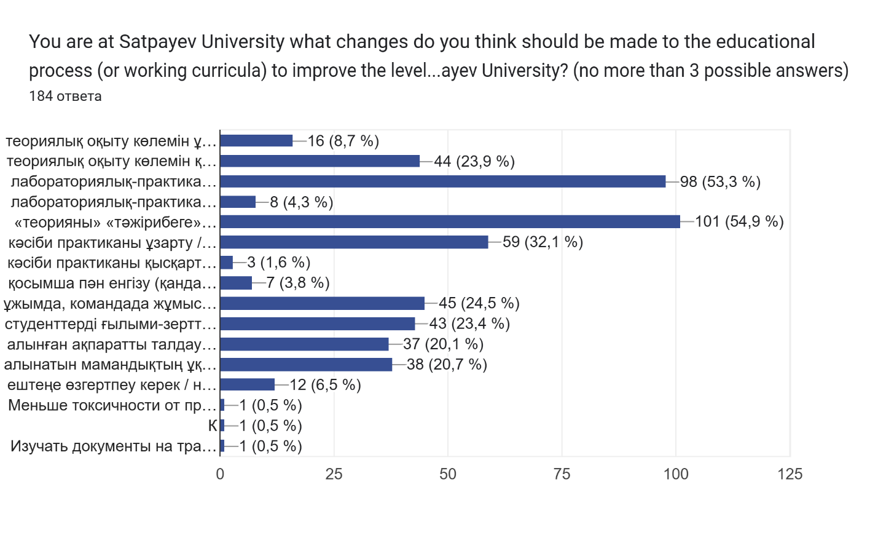
Question 12: What are your most positive impressions of the university?
Most students positively assessed a strong and responsive teaching staff (35.5%) and a vibrant student life with extracurricular activities (33.9%). These aspects shape a positive image of the university and foster student engagement.
Academic and social support (7.7%), living and dining conditions (7.1%), research activity (4.9%), and industrial internship (4.4%) were mentioned less frequently. Laboratory classes were noted by only 1.6% of respondents.
In individual answers, graduates made remarks and suggestions concerning faculty work, infrastructure, and the organization of the educational process—pointing to particular aspects that deserve additional attention.
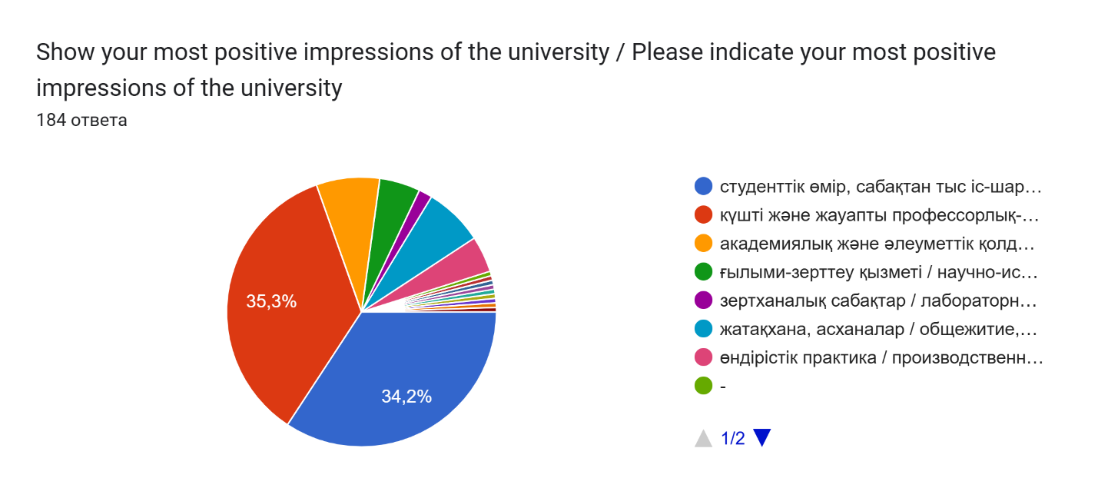
Question 13: Are you currently working in your specialty?
Most graduates (60.7%) reported that they are working in their specialty. Another 17.5% are employed in a related field, which may indicate the flexibility of the education received and its applicability in adjacent areas.
At the same time, 21.9% are not working in their specialty, which may point to difficulties with employment, changes in professional interests, or an insufficient link between the curriculum and labor-market requirements.
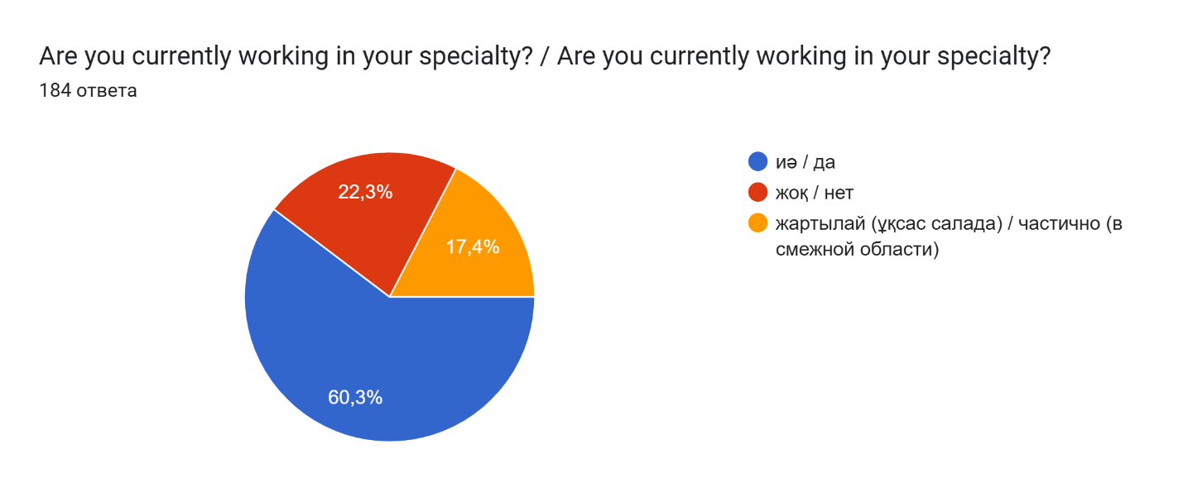
Question 14: What salary do you currently receive?
At the time of the survey, most graduates (43.7%) were earning between 200,000 and 400,000 tenge. Almost a third (26.8%) were earning 400,000–600,000 tenge, and 22.4%—less than 200,000 tenge. Only 7.1% indicated incomes above these ranges.
These data reflect the initial income level of young specialists and can serve as a reference point for assessing how effectively graduates are prepared for the labor market. Lower salaries among some respondents may be associated with the early career stage, internships, or work outside their primary specialty.
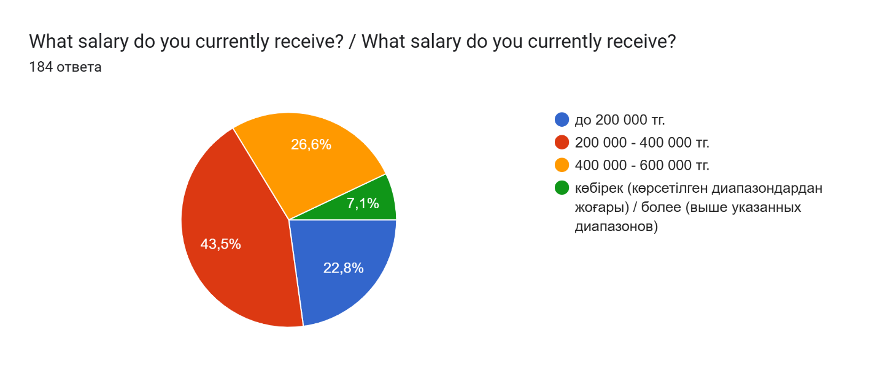
The survey shows that most graduates positively evaluate the quality of education and professional training received at the university. Nearly half noted a high level of theoretical and practical knowledge, as well as the development of critical thinking and teamwork skills—evidence of a solid academic foundation and the university’s ability to build key competencies.
At the same time, students expressed a clear demand for a more practice-oriented approach: more than 50% favor reducing theory in favor of practical classes and actively involving industry specialists and modern equipment in the learning process.
Career support from the university received mixed assessments. While more than half noted help in finding internships and participation in job fairs, about a quarter did not feel such support—indicating a need for more systematic and accessible employment services.
Financial expectations and realities also reflect the early stage of graduates’ professional paths: most earn 200,000–400,000 tenge, and only 7% earn above that level. More than 60% are already working in their specialty, confirming the relevance of their education, though one fifth are employed outside their field.
Students’ positive impressions are primarily linked to the teaching staff and student life. Infrastructure, research activities, and laboratory classes were less prominent, suggesting directions for further development.
Overall, the survey results reflect a positive perception of the educational process and reveal potential for further improvement of academic programs in line with labor-market needs.

